Potential exam questions:

1. What is the difference between a paradigm, a theory and a model?
2. What were Adam Smith’s main arguments for, and against government involvement in the economy?
3. Explain Thomas Malthus’ theory of population
4. Explain what is happening in the following graph:

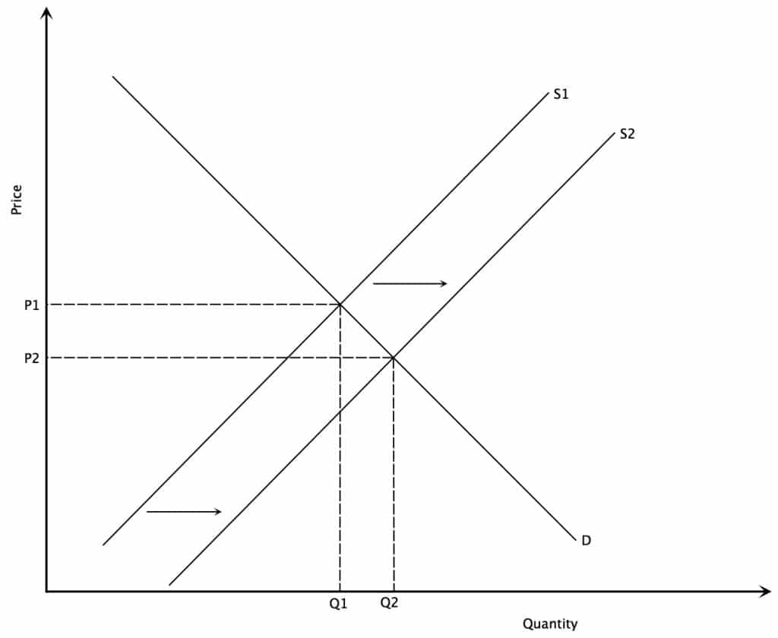

1. What determines the value of a good according to Alfred Marshall (1842-1924)?
2. What is capitalism?
3. What characterizes the Marxist method?
4. Explain Marx’s labour theory of value.
5. What are the main Marxist critiques of capitalism?
6. What was the fundamental characteristic of the Great Depression according to Keynes?
7. According to Galbraith, who was *“The true protagonist of the Kynsian ideas”,* and why?
8. What makes the labour market different from other markets according to Keneys?
9. What characterizes Galbraith’s three forms of power?
10. What does Schumpeter mean by *“Creative destruction”*?
11. Why does Reinert argue that it is better for a country to produce golf balls than baseballs?
12. From an evolutionary economics perspective, explain the developmental success of either England or Japan.
13. In relation to inequality, discuss what Reinert describes as *the Scandinavian Fallacy*:

*“…a frame of mind where complex problems of poverty, rather than being attacked from the inside by improving the system of production, are solved by throwing money after them from the outside.”*

1. According to Reinert and/or Studwell (2013), why should industries be protected only temporarily?
2. What do you think is the best way to restructure the economy in order to achieve the political goal of <2°C warming, and why?
3. Analyse the financial crisis from different theoretical perspective.